**W1-S2** GROUP REFLECTION

*Design Principles*

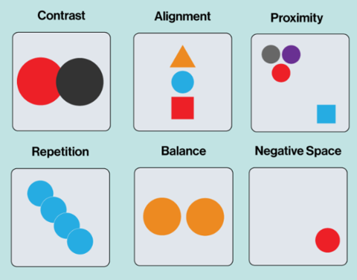

For this session: Make groups of 3 students.

|  |  |
| --- | --- |
|  | Group work *(60 min)* |

You need to need to analyze **3 graphical designs** (choose among the ones bellow)

* Complete the evaluation table for each analysis
* Propose improvements if needed *(just ideas. You don’t have to draw anything)*

|  |  |
| --- | --- |
|  | Group presentations *(15 min)* |

It’s time to share you group work to the whole class

* 1 speaker per group
* Speakers are randomly selected to present each group work activity

Teammates:

Chey Naryvety

Bouy Dara

Lim Vinchay

*WORK 1*

Which design you choose? (letter): A

|  |  |  |
| --- | --- | --- |
| *CATEGORY* | *CRITERIA* | *YOUR ANLAYSIS* |
| CONTRAST | * Does the design use enough contrast to differentiate elements? * Do the elements with high contrast stand out as intended? | No, the contrast is really poor. Black and white is a good color that contrast each other but it’s ultimately plain. Each section for Breakfast and lunch only has a single underline to differentiate them, there is no visual weigh no color contrast. Nothing really stands out. |
| ALIGNMENT | * Are text, images, and other elements aligned properly to create order and cohesiveness? * Are there any elements that feel "out of place"? | Texts aren’t very well aligned. CADT restaurant should be in the center to grab attention. The prices are not aligned with one another making it hard to look for and make them feel “out of place” especially the last part where the price is missing |
| PROXIMITY | * Are headlines, body text, and images that belong together placed near each other? * Are elements spaced too far apart or too close together? | Each dish name and their description are all evenly spaced to one another/too close to each other making it hard to determine the difference between the dish and its description. |
| REPETITION | * Are colors, fonts, or shapes used consistently across the design? * Does the repetition feel intentional and effective? | The color and fonts are consistent but the change in price from “_$” to “price can change” is really off making it inconsistent there.  The whole design is repetitive in a bad way. It is plain and boring. |
| WHITE SPACE | * Does the design have enough white space to avoid overcrowding, or does it feel empty? * Is the white space used to guide the viewer's eye effectively? | It feels overcrowded due to lack of spacing between each section and each dish.  Theres no break, no whitespace for the viewer to actually know what to focus on or what to read. |
| BALANCE | * Is the design the same on both sides or does one side have more weight than the other? * Does the design feel even and comfortable to look at, or does it feel lopsided and uneven? | It’s unbalanced as everything is aligned to the left making it “heavy” toward the left side.  It feels uncomfortable to look at it’s chaotic. |
| **IMPROVEMENTS** | * Write your improvement proposition (*If any)* | **Create more contrast to differentiate the heading/title, each section and each dish. Fix the alignment. Make better grouping. Fix typo, the “fired chicken” part should be “fried”** |

*WORK 2*

Which design you choose? (letter): F

|  |  |  |
| --- | --- | --- |
| *CATEGORY* | *CRITERIA* | *YOUR ANLAYSIS* |
| CONTRAST | * Does the design use enough contrast to differentiate elements? * Do the elements with high contrast stand out as intended? | Yes, but it can be improved. The heading “create a new race” have a good and high contrast by using font color and bg color. The field labels and the information that you fill in is a bit too alike, it lacks distinction.  Yes, they do partially but the swim section feels off cus it looks like a label |
| ALIGNMENT | * Are text, images, and other elements aligned properly to create order and cohesiveness? * Are there any elements that feel "out of place"? | No, the swim text is not aligned with the rest of the input.  Yes, the texts in the two buttons on the bottom doesn’t feel like it’s aligned properly in the center. |
| PROXIMITY | * Are headlines, body text, and images that belong together placed near each other? * Are elements spaced too far apart or too close together? | They are placed nicely together and related to each other creating a clear grouping.  They mostly good only the bottom part between the swim segment and the two buttons feels a bit cramped. |
| REPETITION | * Are colors, fonts, or shapes used consistently across the design? * Does the repetition feel intentional and effective? | Yes, color is good but the boldness is not consistent. Everything was bold until the text on those buttons which look off.  No the ambiguous/inconsistent of the two bottom elements makes it feel unplanned and ruined the overall. |
| WHITE SPACE | * Does the design have enough white space to avoid overcrowding, or does it feel empty? * Is the white space used to guide the viewer's eye effectively? | It is nice. Good amount of white to avoid crowding.  Yes, the white space was used well to guide the viewer down each section except for the last bit. |
| BALANCE | * Is the design the same on both sides or does one side have more weight than the other? * Does the design feel even and comfortable to look at, or does it feel lopsided and uneven? | The overall balance is okay.  It feels comfortable for the main form but becomes slightly awkward and bottom-heavy with the unclear elements at the bottom. |
| **IMPROVEMENTS** | * Write your improvement proposition (*If any)* | **Change up the bottom section according to the criticism above.** |

*WORK 3*

Which design you choose? (letter): H

|  |  |  |
| --- | --- | --- |
| *CATEGORY* | *CRITERIA* | *YOUR ANLAYSIS* |
| CONTRAST | * Does the design use enough contrast to differentiate elements? * Do the elements with high contrast stand out as intended? | Yes, the colors are used perfectly white/black/red goes well tgt and got good contrast.  The "Enjoy again and again and again." is the clear focal point. and the legal disclaimer is low-contrast giving it less focus |
| ALIGNMENT | * Are text, images, and other elements aligned properly to create order and cohesiveness? * Are there any elements that feel "out of place"? | Texts are well aligned and balance creating a clean-looking ads.  No elements feel out of place. |
| PROXIMITY | * Are headlines, body text, and images that belong together placed near each other? * Are elements spaced too far apart or too close together? | No, all elements are well placed, each section like the disclaimer is properly put at the bottom a bit separated from the rest.  The elements aren’t spaced too far or too close they are nicely grouped tgt with an appropriate amount of space |
| REPETITION | * Are colors, fonts, or shapes used consistently across the design? * Does the repetition feel intentional and effective? | Yes, the font is consistent and the color palette is limited yet intentional for the brand (red/black/white).  The repetition of word used “again and again” feels intentional and effective for branding reinforcing the message |
| WHITE SPACE | * Does the design have enough white space to avoid overcrowding, or does it feel empty? * Is the white space used to guide the viewer's eye effectively? | Yes, this is a very good use of white space. Theres evenly placed padding around the texts and elements.  Yes, everything looks clean and well-put tgt making it easy for viewer to focus on the message |
| BALANCE | * Is the design the same on both sides or does one side have more weight than the other? * Does the design feel even and comfortable to look at, or does it feel lopsided and uneven? | The design has symmetrical balanced to it. It is overall well balanced.  It is very comfortable and professional to look at. |
| **IMPROVEMENTS** | * Write your improvement proposition (*If any)* | **It’s good to de-emphasized some texts to shift focus but the disclaimer should be a bit more noticeable since it’s important.** |

*DESIGN A*

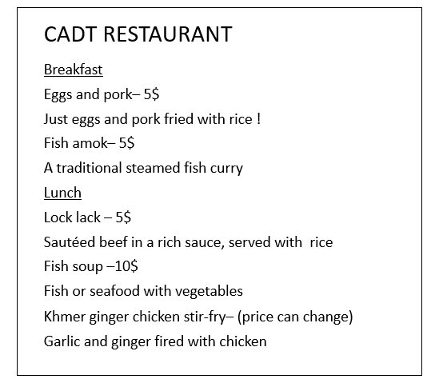

*DESIGN B*

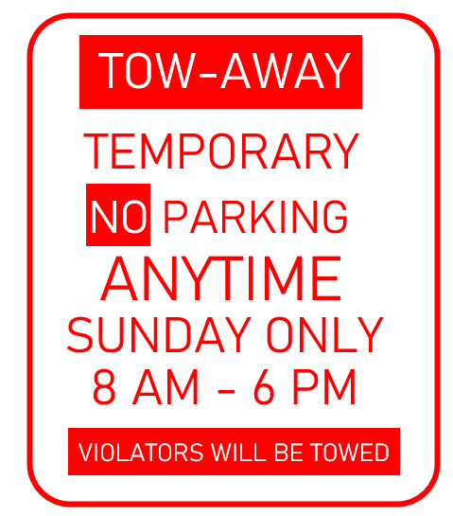

*DESIGN C*

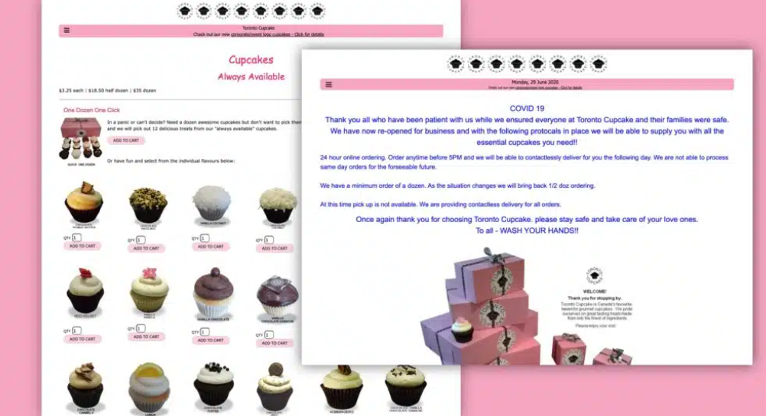

*DESIGN D*

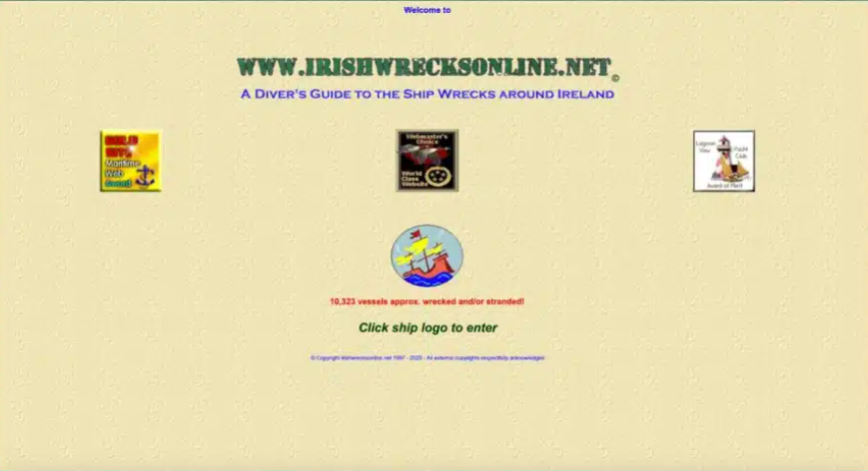

*DESIGN E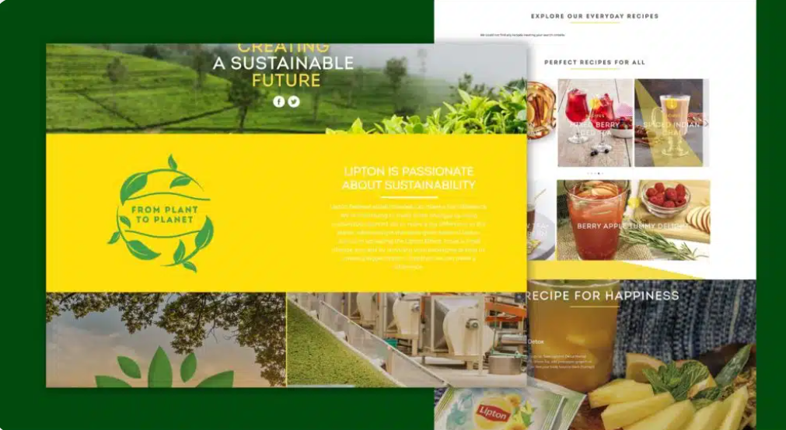*

*DESIGN F*

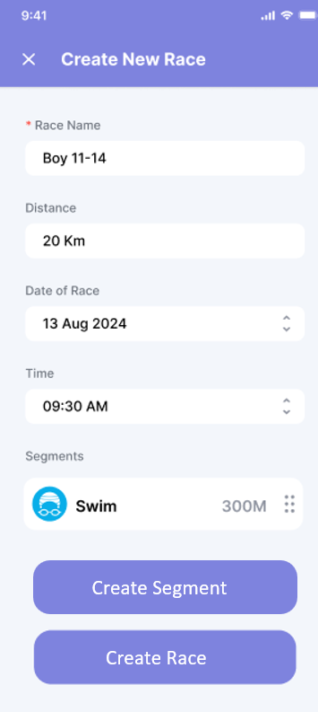

*DESIGN G*

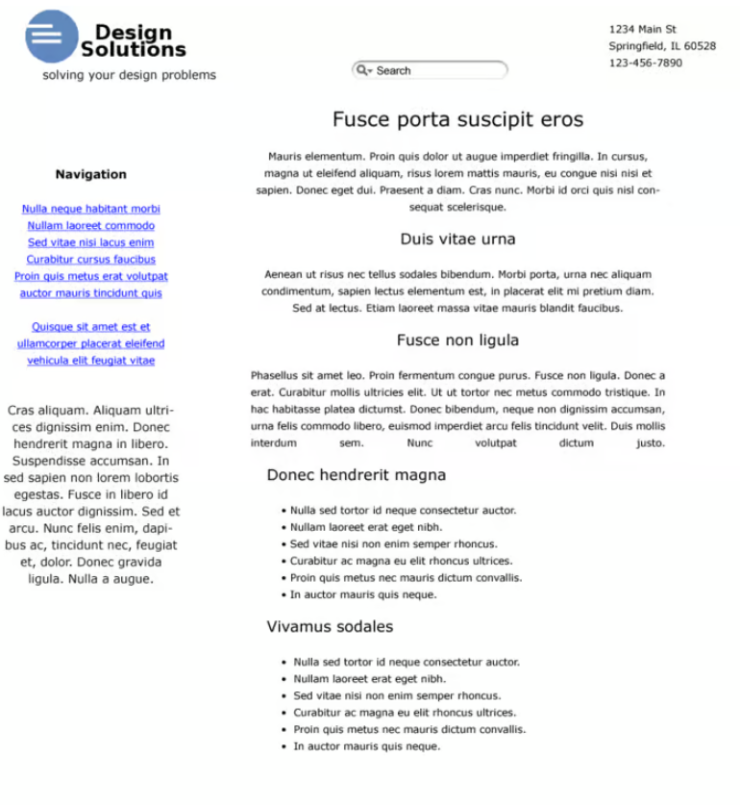

*DESIGN H*

